Tetriling Puzzle Report 07/12/17

The method utilized in this report is a mixture of traditional algorithmic programming and machine learning techniques, utilizing the strengths of each approach.

The convolutional neural network used in this method consists of a neural network consisting of a 7x7 input layer, 2 convolutional layers with 49 filters each, 1 pooling layer, 1 dropout layer and an output layer of size 76. It is ideal to keep the architecture as small as possible as the number of computations increases with network size.
The network takes in as input a 7x7 region of the target and outputs a size 76 vector, each value in the vector representing the probability that the central square of the region has a given Block ID in the range of 0-75 as demonstrated in Figure 2.
To train the network, a labelled dataset is required of 7x7 regions and the corresponding correct Block ID of the central square in the solution. This is generated using the conv_dataset_gen.py file. It uses a modified version of the function in utils called generate_target so that is not only outputs the target but also the Block ID of each piece in the solution for the generated target. This modified function is used to generate 452,000 pairs of inputs and correct outputs and saves this data in a serialized pickle file.
The network is then trained in the conv_deep_learning.py file. In this file, the neural network model is built and then trained for 5 epochs using stochastic gradient descent on the imported and un-serialized dataset. An epoch is defined as when the network has backpropagated for each item in the training set once.
The trained model is then saved so it can be imported and used by other programs.

All of the above is implemented using a numerical computation library called Tensorflow. This library allows the algorithm to run utilizing all cores of the computer and the GPU which significantly reduces the training time.
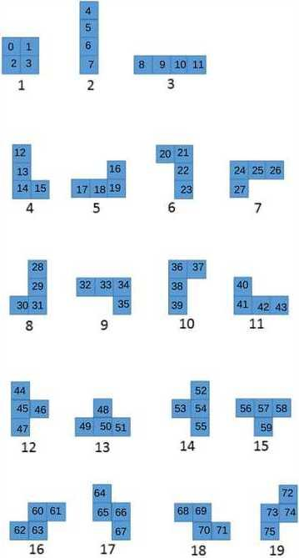
Figure 2 – Block ID
Main algorithm
The problem of tiling a large target is reduced to the problem of classifying which shape goes in the central square of a 7x7 grid of the target repetitively.
The algorithm starts by scanning the target variable starting from the top left to the bottom right using a for loop. It stops each time it arrives at a 1 and attempts to classify it into one of 76 squares belonging to a shape as shown in figure 2.
This is done by first extracting the 7x7 submatrix from the target with the square being classified as the centre one. In the code, this is called submat.
To do this, a list of so called ‘filters’ is created where each filter is a 2-item tuple representing a co-ordinate relative to the centre square of submat. Each square identified by each filter is checked to see if it needs to be covered by a shape. For each square being checked, if the square does not need to be filled, the shapes which, when placed, would lead to excess can be eliminated. There are in total 24 possible squares which can be part of the shape which is placed down, as shown in Figure 3, so there are 24 filters in total. Once all the filters have been applied, there remains a list containing all the possible Block IDs which when placed, do not lead to excess squares or errors. This list is called possible_class.

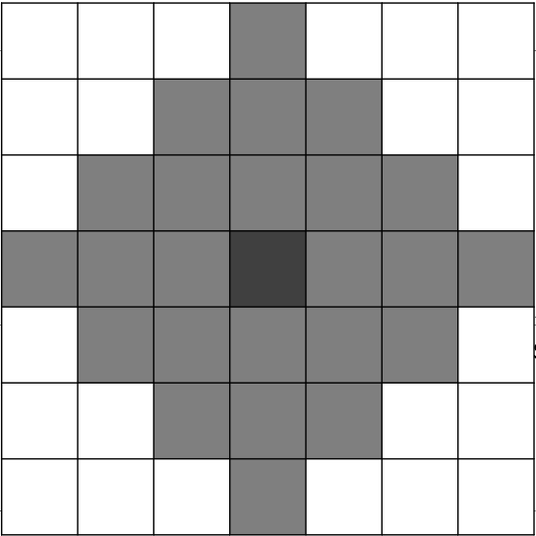
Now, submat is fed into a convolutional neural network which takes in as input a 7x7 submatrix of target and outputs a vector representing the probability that the central square belongs to each class. Details of how this network is trained are discussed later on. The argmax of the output vector represents the Block Id to which the network has assigned the highest probability of being the correct class of the central square. This variable is called o. it is checked if value of o is in possible_class. If it is, the central square is classified as having Block ID of o. If it is not the network has guessed incorrectly so the first item in the list possible_class is assigned to the classification of the central square. Given the class of the square, the shape is added to the solution variable and removed from target.
Figure 3 – squares which can be part of the shape placed on the central square

This is repeated until there the bottom right corner is reached at which point the problem is considered solved with solution storing the solution.

An example walkthrough solution is demonstrated for a 4x4 target in Figure 4.

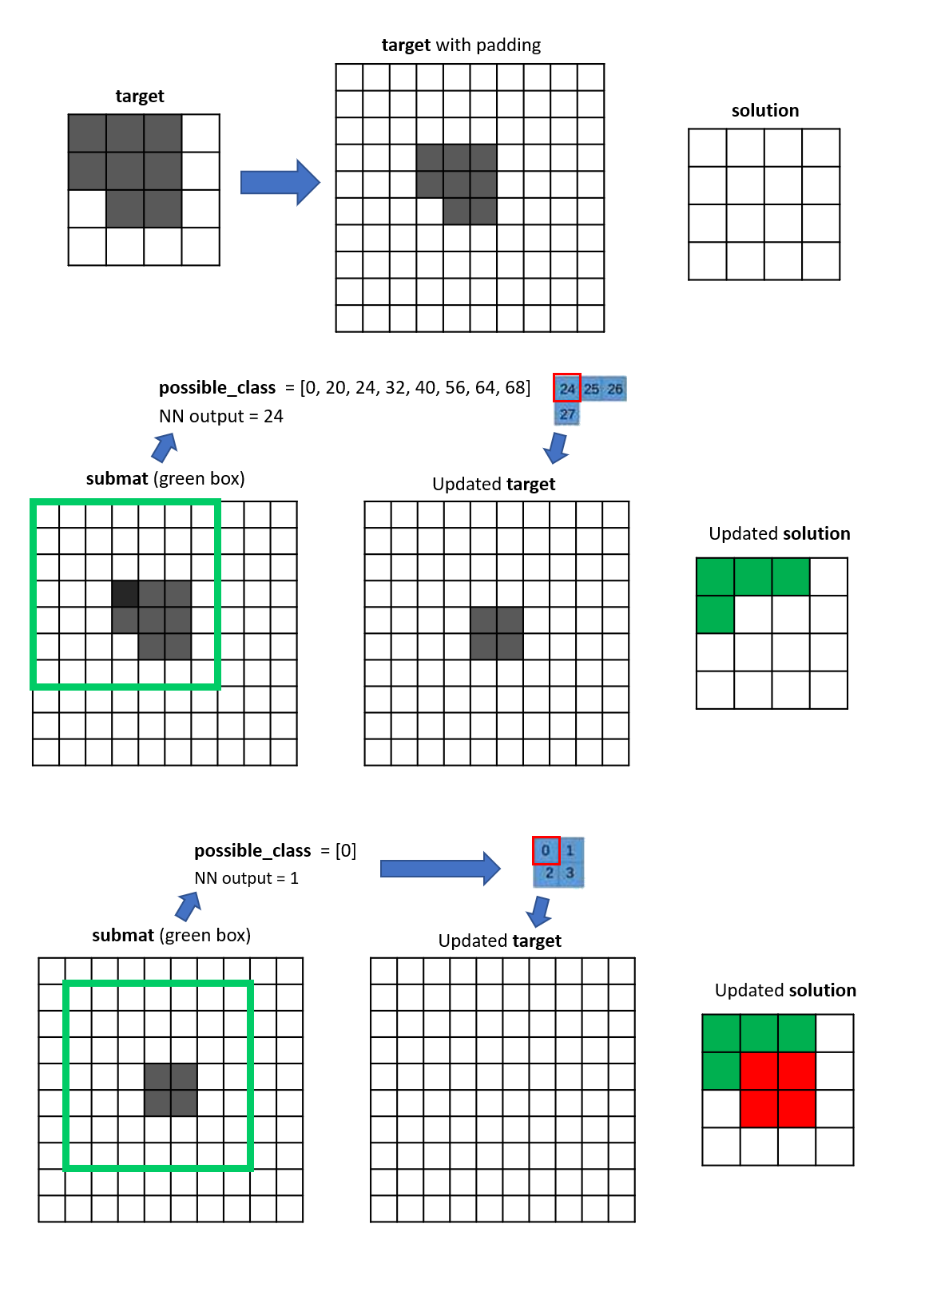
Figure 4

